**Quiz – Week 2**

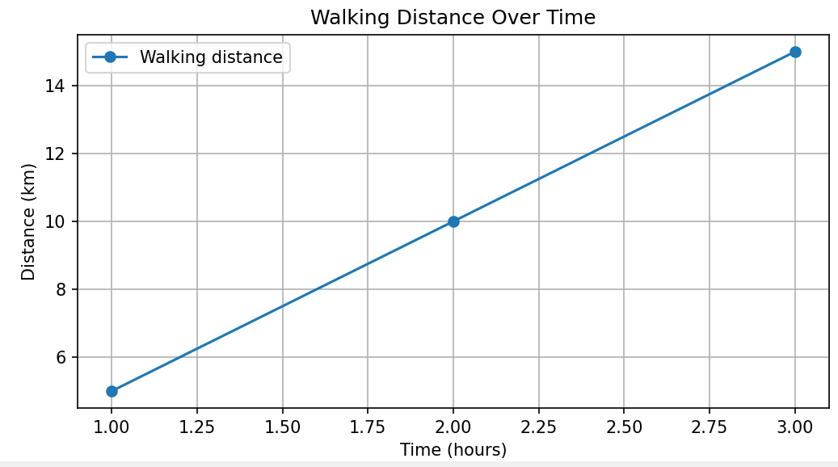

Figure 1

Question 1: Like shown in figure 1, if Khurram walks 5 km in 1 hour, 10 km in 2 hours, 15km in 3 hours. How far will he walk in 4 hours?

* 1. 5km
  2. 25km
  3. 17km
  4. 20km
  5. 1km

Figure 2

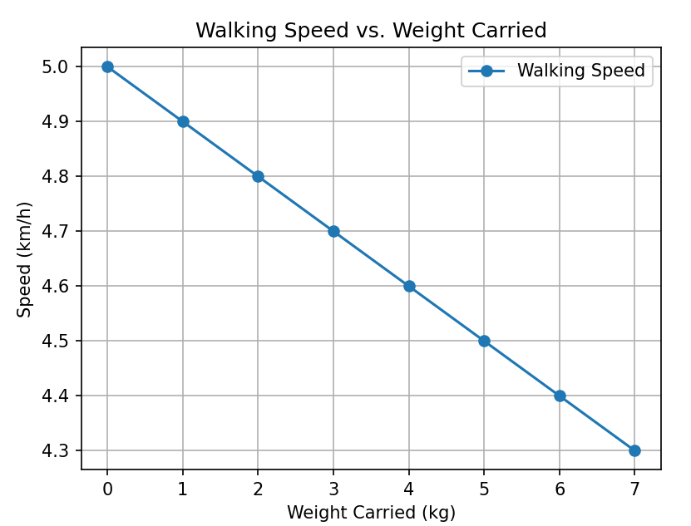

Quesiton 2: As shown in figure 2, if Atif walks

* 5 km / hour while carrying no weight
* 4.8 km / hour while carrying 2 kg weight
* 4.6 km / hour while carrying 4 kg weight
* 4.4 km / hour while carrying 6 kg weight
* 4.2 km / hour while carrying 8 kg weight

What distance will he cover if he walks for 2 hours, while carrying a 10 kg weight?

Question 3: What is the difference between classification and regression algorithms?

A) Classification predicts discrete labels or categories, while regression predicts continuous values.

B) Classification predicts continuous values, while regression predicts discrete labels or categories.

C) Classification and regression algorithms are essentially the same, just used for different types of datasets.

D) Classification is only applicable to linear relationships, while regression is suitable for non-linear patterns.

E) Regression is used for image recognition, while classification is used for predicting stock prices.

**Question 4:** What is the primary distinction between class imbalance and data drift in machine learning?

A) Class imbalance refers to an unequal distribution of instances across different classes, while data drift is the evolution of the input data distribution over time.

B) Class imbalance occurs when the model is biased toward a particular class, while data drift is the result of overfitting to the training data.

C) Class imbalance is a form of overfitting, whereas data drift is related to underfitting.

D) Class imbalance and data drift are terms used interchangeably to describe the same concept in machine learning.

**Question 5:** The simplicity of the Naive Bayes algorithm, combined with its effectiveness in handling large datasets and working with the high-dimensional feature space typical in text data, makes it a great choice for applications such as spam detection, sentiment analysis, and topic categorization, where quick and reasonably accurate predictions are more valuable than complex model interpretability.

1. True
2. False